SUNSET RIDGE TOWNHOUSE ASSOCIATION
COURTYARD GATE STANDARD
August 2015
- Scope
  - Scope - This Standard applies to the Courtyard Gates in all Sunset Ridge Townhouse Units
- Purpose
  - Provide guidance to homeowners
  - Encourage investment in individual properties
  - Simplify approval and construction process
  - Promote reasonable uniformity and standardization
  - Assure quality workmanship
  - Increase property values
  - Provide for the improvement of the community
- Applicable Documents
  - Ken-Caryl Ranch Townhouse Association Rules and Regulations (Revised - April 2008)
  - Ken-Caryl Ranch Townhouse Association Policy and Procedures for Vehicle Parking (Dated 11-5-2013)
  - Drawings - N/A
  - Standards - N/A
  - Pictures - These are two examples of how the courtyard gate may be modified
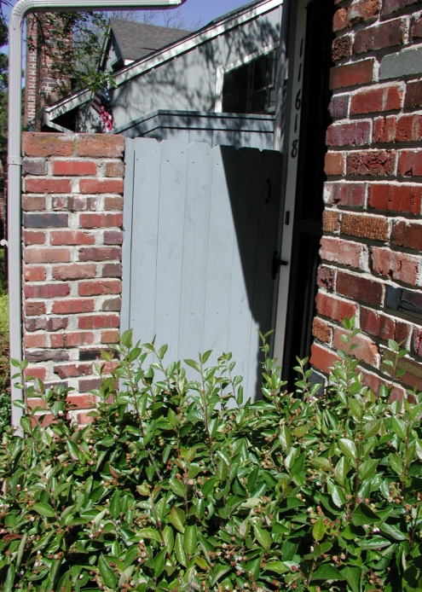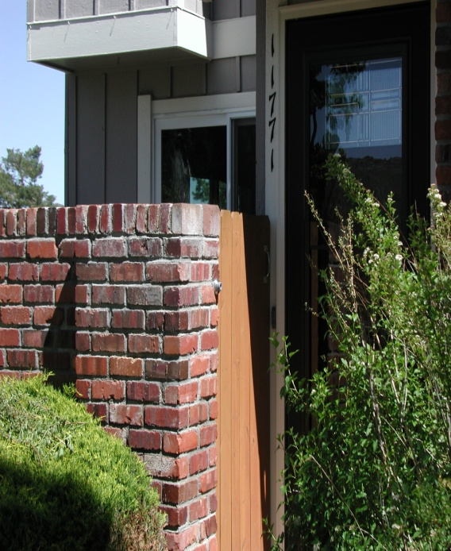

- Definitions
  - Units of measure - English system of measures apply
  - Standard practices - Installation workmanship will be in accordance with approved contractor guidelines
- General Requirements
  - Materials
    - Cedar pickets
  - Size
    - Pickets shall be 5 inches wide to match existing fences at end units and between unit courtyards. Top corners shall be "dog eared".
  - Colors
    - Pickets shall be stained to match existing fences at end units or between unit courtyards
  - Form, Fit and Function
    - Pickets shall be no higher than the brick pilaster
  - Style - Pickets shall match current style used in fences at end units or between unit courtyards
  - Match existing - Pickets
  - Location - Front of unit at courtyard entrance
- Detailed Requirements
  - Quality Control - Installation quality control is the responsibility of the homeowner and the contractor
  - Inspection
    - A Jefferson County Building Permit is NOT required for this work
    - Members of the Architectural, Building & Maintenance Committee are available for inspection of non-permitted work
- Notes
  - Hours of work - Work is permitted between the hours of 7:00 am and 5:00 pm Monday to Friday and between 8:00 am and 5:00 pm on Saturday. Work is not allowed on Sunday.
  - Debris/waste disposal and site clean-up are the responsibility of the homeowner and the contractor/vendor
  - Contractors/vendors are allowed to park in the alleyways while fulfilling their contractual obligations
  - Work shall be scheduled so as not to impact weekly trash pickup, snow removal and/or landscaping activities
  - The Sunset Ridge Townhouse Association Management Company shall be notified when the work begins and when the work is complete
  - A list of contractors/vendors (not qualified by the KCTOA) is available upon request (to be used at homeowner's risk)
  - The Homeowner assumes all liability for themselves, their contractors/vendors, their assigns, and the work preformed

