SUNSET RIDGE TOWNHOUSE ASSOCIATION
GUTTER & DOWNSPOUT STANDARD
August 2015
- Scope
  - Scope - This Standard applies to the replacement of gutters and downspouts in all Sunset Ridge Townhouse Units
- Purpose
  - Provide guidance to homeowners
  - Encourage investment in individual properties
  - Simplify approval and construction process
  - Promote reasonable uniformity and standardization
  - Assure quality workmanship
  - Increase property values
  - Provide for the improvement of the community
  - Properly route the water away from the courtyard
- Applicable Documents
  - Ken-Caryl Ranch Townhouse Association Rules and Regulations (Revised - April 2008)
  - Ken-Caryl Ranch Townhouse Association Policy and Procedures for Vehicle Parking (Dated 11-5-2013)
  - Drawings - N/A
  - Standards - N/A
  - Pictures - These are some examples of how to route the water away from the courtyard

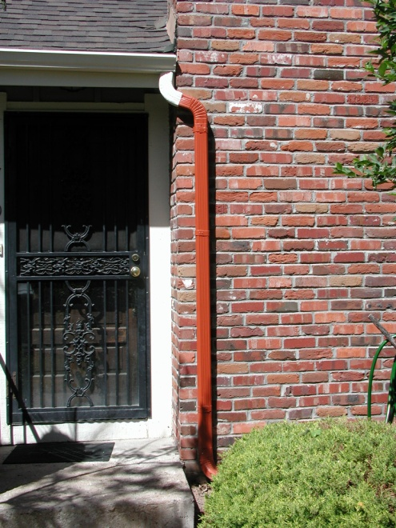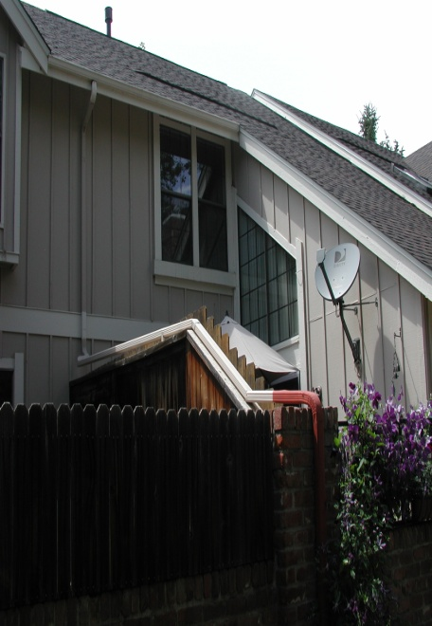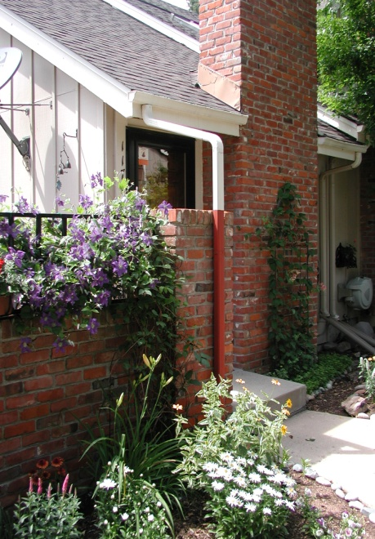

- Definitions
  - Units of measure - English system of measures apply
  - Standard practices - Installation workmanship will be in accordance with approved contractor guidelines
- General Requirements
  - Materials
    - Coated steel is preferred
    - Aluminum is acceptable
    - Vinyl is NOT acceptable
    - Plastic is NOT acceptable
  - Size
    - Gutters shall be 5 inches wide
    - Downspouts shall be 2 inches by 3 inches
  - Colors
    - Gutters shall match the surface to which it is attached (i.e. basic house color, trim color)
    - Downspouts shall match the surface to which it is attached (i.e. basis house color, trim color, "red primer" for brick)
  - Form, Fit and Function
    - Gutters shall have a pre-formed rectangular outlet matching the downspout size for each downspout
    - Gutters shall be sloped toward the downspout
    - Downspouts shall be at an end of the gutter
    - Downspouts adjacent to the front door will no longer be routed through the courtyard area. They shall be relocated to the front of the chimney.
    - Downspouts shall not be installed under decking or patio material (i.e. wood, composite, concrete, brick or pavers)
    - Water exiting downspouts shall outfall onto a impervious surface (i.e. pavement or splash block). The point of discharge from the splash block shall be a minimum of 3-feet away from the building or brick wall.
    - Water exiting downspouts by garage door shall run onto the concrete apron swale.
    - Water exiting into the ground area between garages (alcove) is prohibited.
  - Style - Replacement gutters and downspouts shall be compatible in style to the existing gutters and downspouts
  - Match existing - Installation of gutters and downspouts shall match existing gutter configurations
  - Location
    - Gutters and downspouts identified in 4.4 above shall be located as prescribed
    - All other gutters and downspouts shall match existing locations
  - N/A

- Detailed Requirements
  - Quality Control - Installation quality control is the responsibility of the homeowner and the contractor
  - Inspection
    - A Jefferson County Building Permit is NOT required for this work
    - Members of the Architectural, Building & Maintenance Committee are available for inspection of non-permitted work
- Notes
  - Hours of work - Work is permitted between the hours of 7:00 am and 5:00 pm Monday to Friday and between 8:00 am and 5:00 pm on Saturday. Work is not allowed on Sunday.
  - Debris/waste disposal and site clean-up are the responsibility of the homeowner and the contractor/vendor
  - Contractors/vendors are allowed to park in the alleyways while fulfilling their contractual obligations
  - Work shall be scheduled so as not to impact weekly trash pickup, snow removal and/or landscaping activities
  - The Sunset Ridge Townhouse Association Management Company shall be notified when the work begins and when the work is complete
  - A list of contractors/vendors (not qualified by the KCTOA) is available upon request (to be used at homeowner's risk)
  - The Homeowner assumes all liability for themselves, their contractors/vendors, their assigns, and the work preformed

