SUNSET RIDGE TOWNHOUSE ASSOCIATION
Skylight Replacement and New Installation Standard
June 2017
- Scope
  - Scope - This Standard applies to the addition or replacement of Skylights in all Sunset Ridge Townhouse Units
- Purpose
  - Provide guidance to Homeowners
  - Encourage investment in individual properties
  - Simplify approval and construction process
  - Promote reasonable uniformity and standardization
  - Assure quality workmanship
  - Increase property values
  - Provide for the improvement of the community
- Applicable Documents
  - Ken-Caryl Ranch Townhouse Association Rules and Regulations (Revised - April 2008)
  - Ken-Caryl Ranch Townhouse Association Policy and Procedures for Vehicle Parking (Dated 11-5-2013)
  - Warranty – Roof Warranty, Heritage Roofing Inc., dated July 2014.
  - Drawings – New installations shall require a drawing showing the proposed location of where the new skylight will sit in relation to the roof surface.
  - Standards – N/A
  - Pictures –

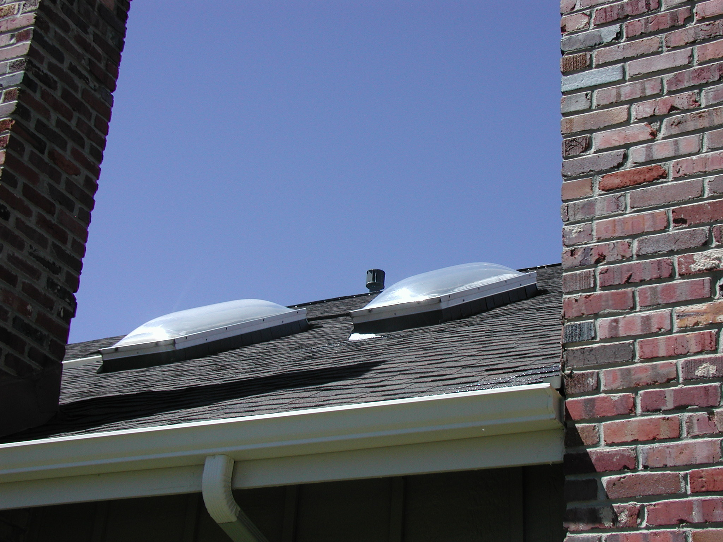
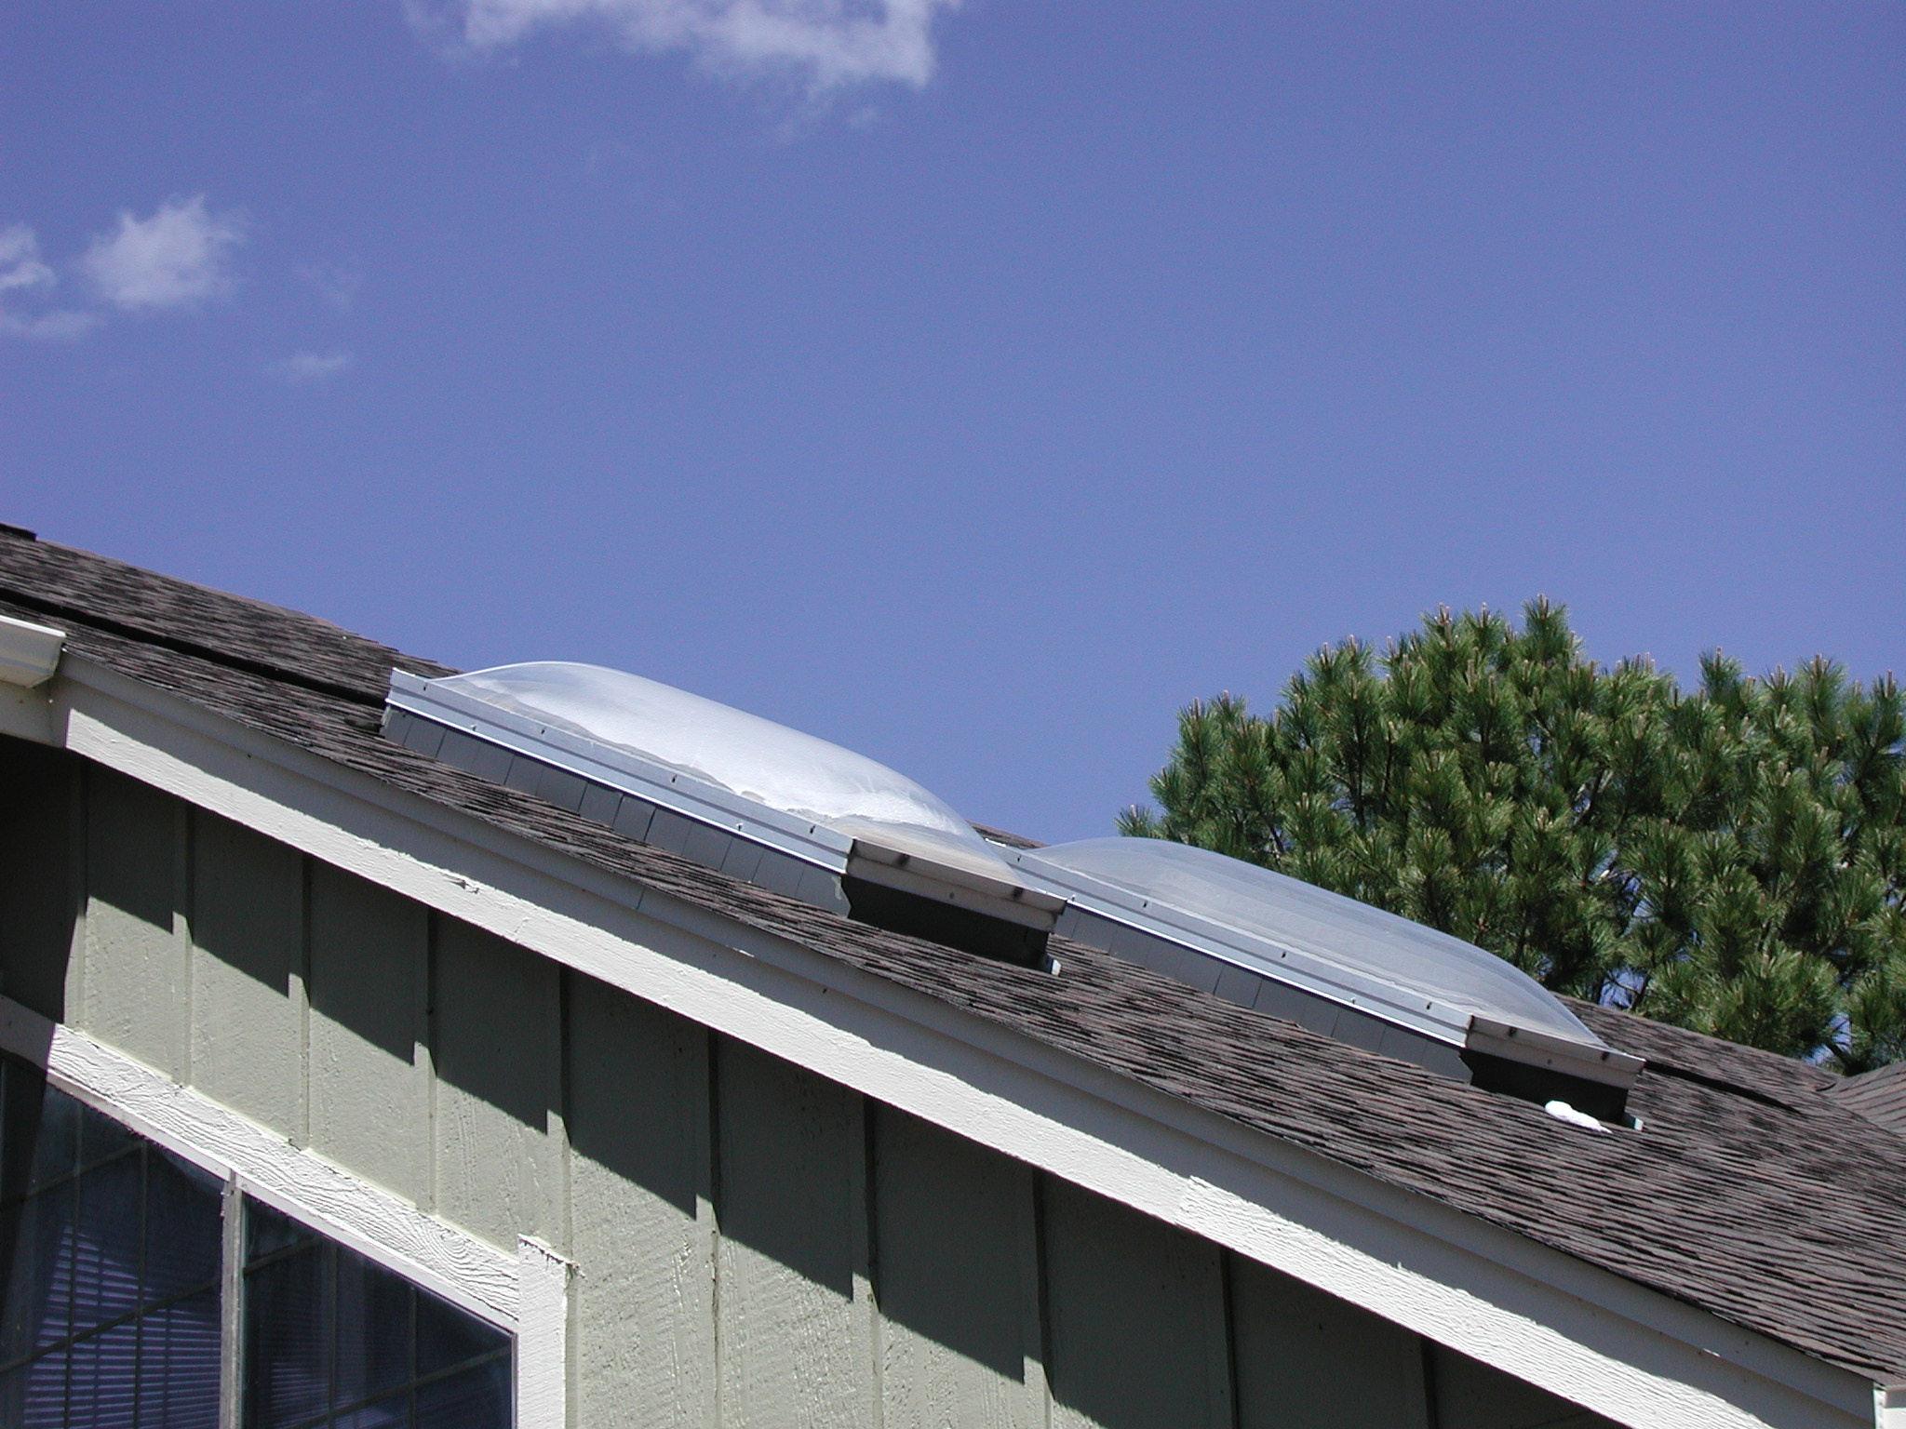

- Definitions
  - Units of measure - English system of measures apply
  - Standard practices - Installation workmanship will be in accordance with approved contractor guidelines
- General Requirements
  - Materials
    - Existing skylight replacement: Aluminum, Double pane thermal panel glass.
    - New installation: Aluminum, solid or clad exterior. Double pane thermal panel glass.
  - Size: Replacement, Must match existing curb built into the roofing system
  - Size: New addition, 24" x 24" or 24" x 48" New unit must be supported on each side by the existing roof trusses. No modifications of any kind to the roof trusses is permissible other than to add 2"x 4" support blocks at the top and bottom of the new opening. Consult with a licensed contractor, as appropriate for exact sizing.
  - Fit and Function for existing: Unit must be the same shape as existing so it will fit over the existing curb without modification. Unit can be fixed or operable but must have the same general shape when closed as viewed from the outside of the structure.
  - Fit and Function for new installation: Unit shape must have the same general appearance as the existing original skylights for the purpose of continuity. Unit can be fixed or operable but must have the same general shape when closed as the existing units when viewed from the outside of the structure.
  - Color:
Dark bronze or bare aluminum
  - Location:
    - Location of existing:
Living room ceiling as constructed by original builder
    - Location of new installation:
Roof plane on garage side of structure: not closer than 3 feet from ridge line or 4 feet from edge of roof at the gutter line.
- Detailed Requirements
  - As an attachment to the related Home Improvement Request, Homeowner shall submit manufacturer’s product literature/brochure for the desired Skylight and Jefferson County Building Permit, if required by the County.
  - Inspection
    - A Jefferson County Building Permit may be required. [Note: It is the Homeowner’s responsibility (or that of their Contractor, as directed by Homeowner) to contact the Jefferson County Building Department to determine whether a Building Permit is required and, if so, to secure such a Permit. The Jefferson County Building Department can be reached at: 303-271-8260.
    - Members of the Architectural, Building & Maintenance Committee are available for inspection of non-permitted work.
    - It is the Homeowner’s responsibility to insure that the Roof Warranty (Para. 3.3) is not violated.

- Notes
  - Hours of work - Work is permitted between the hours of 7:00 am and 5:00 pm Monday to Friday and between 8:00 am and 5:00 pm on Saturday. Work is not allowed on Sunday.
  - Debris/waste disposal and site clean-up are the responsibility of the Homeowner and the contractor/vendor
  - Contractors/vendors are allowed to park in the alleyways while fulfilling their contractual obligations
  - Work shall be scheduled so as not to impact weekly trash pickup, snow removal and/or landscaping maintenance activities
  - The Sunset Ridge Townhouse Association Management Company shall be notified when the work begins and when the work is complete
  - The Homeowner assumes all liability and responsibility for themselves, their contractors/vendors, their assigns, and the work performed

