SUNSET RIDGE TOWNHOUSE ASSOCIATION
COURTYARD AWNING STANDARD
May 2017

- Scope
  - Scope - This standard applies the installation of an awning in the courtyard area
- Purpose
  - Provide guidance to homeowners
  - Encourage investment in individual properties
  - Simplify approval and construction process
  - Promote reasonable uniformity and standardization
  - Assure quality workmanship
  - Increase property values
  - Provide for the improvement of the community
- Applicable Documents
  - Ken-Caryl Ranch Townhouse Association Rules and Regulations (Revised - April 2008)
  - Ken-Caryl Ranch Townhouse Association Policy and Procedures for Vehicle Parking (Dated 11-5-2013)
  - Drawings – N/A
  - Standards –
    - Courtyard Gate Standard
    - Courtyard Iron Grill Work Standard
  - Pictures –
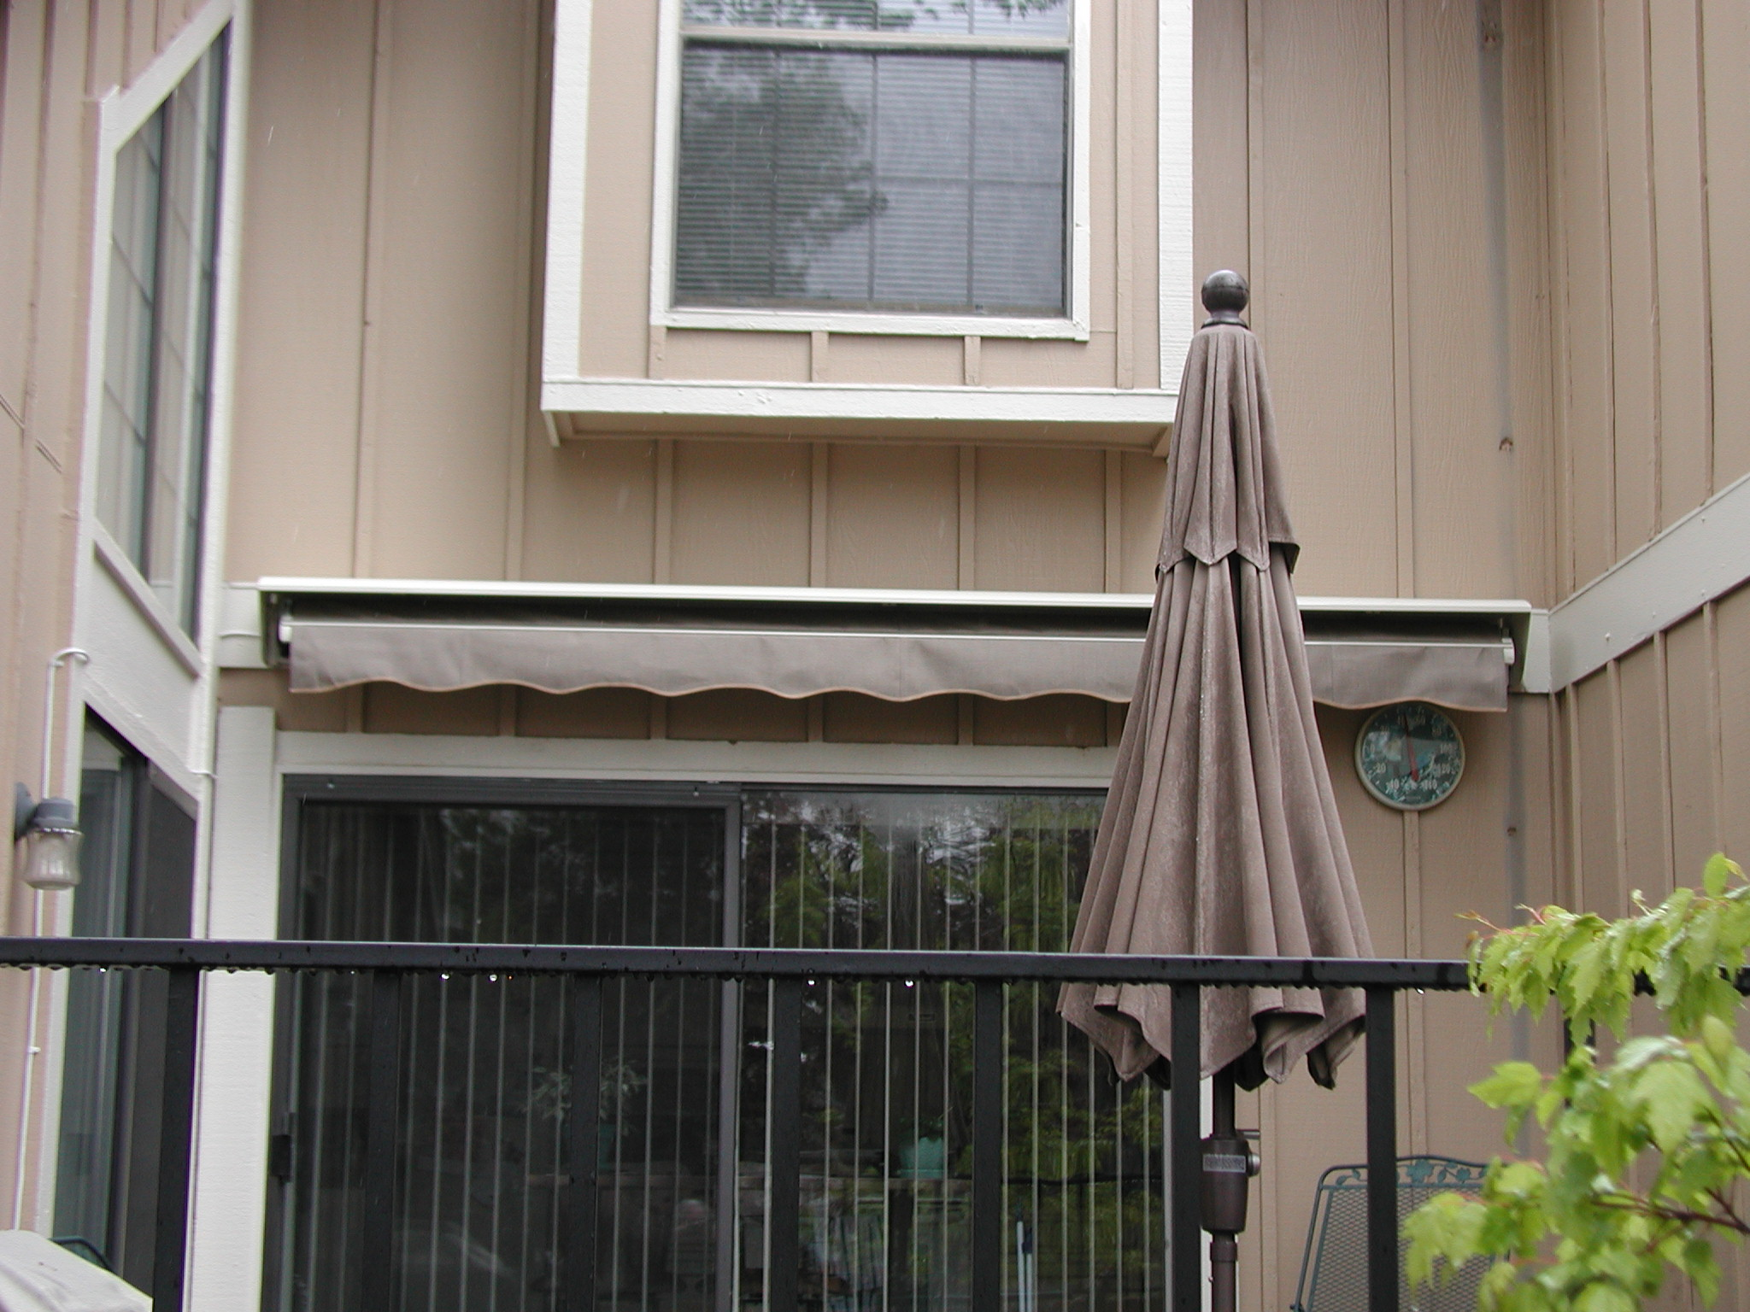
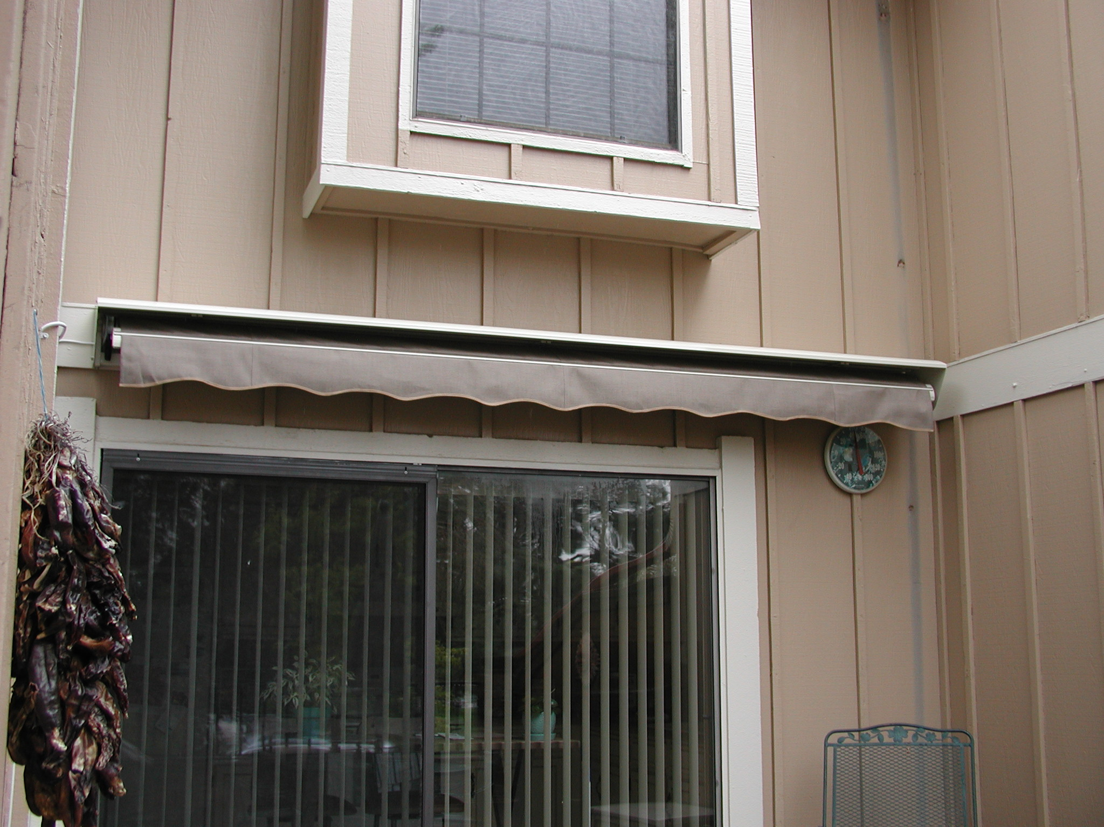

- Definitions
  - Units of measure - English system of measure apply
  - Standard practices – Installation workmanship will be in accordance with approved contractor guidelines
- General Requirements
  - Materials
    - Awning Materials
      - Acrylic Fabric
      - Laminated Fabric
      - Vinyl
      - Polyester
      - Canvas
      - Materials should be flame resistant
    - Retractable Frame Materials
      - Aluminum
      - Steel
      - Iron
  - Size – Awning shall not exceed the courtyard footprint
  - Colors
    - Earth Tones and white are acceptable awning colors
    - Bright Reds, Greens ,Yellows are NOT acceptable awning colors
  - Form, fit, function
    - Awning shall be retractable
    - Awning may be crank operated or motor driven
    - Awning shall be attached to a 2x 6 solid header, properly flashed and caulked, above sliding glass door
    - Awning shall be wind resistant
  - Style – N/A
  - Match existing – N/A
  - Location - Courtyard
- Detailed Requirements
  - As an attachment to the Home Improvement Request Form, the Homeowner shall submit manufacturer’s product brochures for the desired awning
  - Quality Control – Installation quality control is the responsibility of the Homeowner and the contractor
  - Inspection
    - Jefferson Country Building permit maybe required
    - Members of the Architectural, Building & Maintenance Committee are available for inspection of non-permitted work
  - Maintenance – Maintenance of awning, retractable frame and operating mechanism is the sole responsibility of the Homeowner.

- Notes
  - Hours of work - Work is permitted between the hours of 7:00 am and 5:00 pm Monday to Friday and between 8:00 am and 5:00 pm on Saturday. Work is not allowed on Sunday
  - Debris/waste disposal and site clean-up are the responsibility of the homeowner and the contractor/vendor
  - Contractors/vendors are allowed to park in the alleyways while fulfilling the contractual obligations
  - Work shall be scheduled so as not to impact weekly trash pickup, snow removal and/or landscaping activities
  - The Sunset Ridge Townhouse Association Management Company shall be notified when the work begins and when the work is complete
  - A list of contractors/vendors (not qualified by the KCTOA) is available upon request (to be used at homeowner's risk)
  - The homeowner assumes all liability for themselves, their contractors/vendors, their assigns, and the work preformed.

