SUNSET RIDGE TOWNHOUSE ASSOCIATION
Patio Fence Replacement Standard
June 2017
1. Scope
1.1. Scope - This Standard applies to the replacement of Patio Fences in all Sunset Ridge Townhouse Units
2. Purpose
2.1. Provide guidance to Homeowners
2.2. Encourage investment in individual properties
2.3. Simplify approval and construction process
2.4. Promote reasonable uniformity and standardization
2.5. Assure quality workmanship
2.6. Increase property values
2.7. Provide for the improvement of the community
3. Applicable Documents
3.1. Ken-Caryl Ranch Townhouse Association Rules and Regulations (Revised - April 2008)
3.2. Ken-Caryl Ranch Townhouse Association Policy and Procedures for Vehicle Parking (Dated 11-5-
2013)
3.3. Drawings - N/A
3.4. Standards - Gutter & Downspout Standard Dated July 2015
3.5. Pictures-

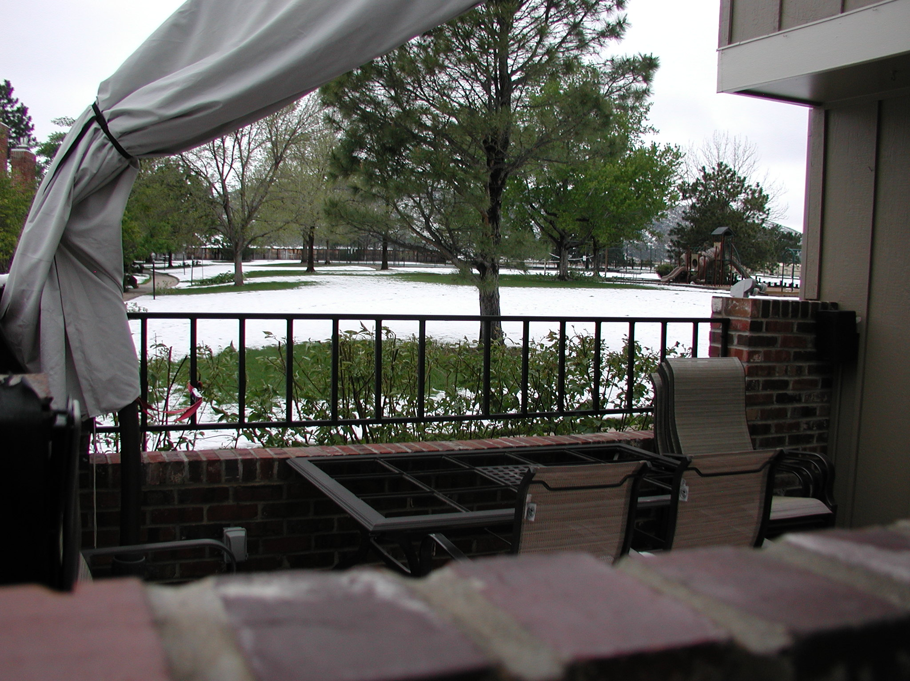
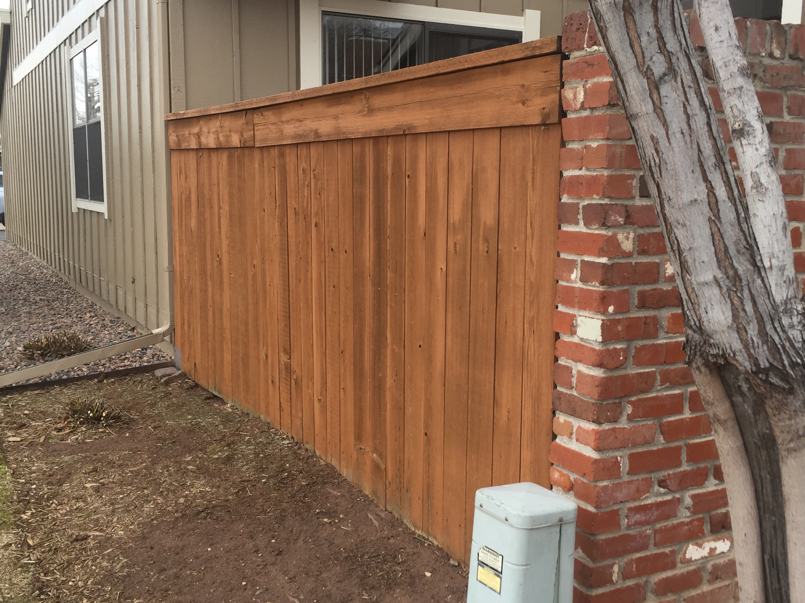

End Fences

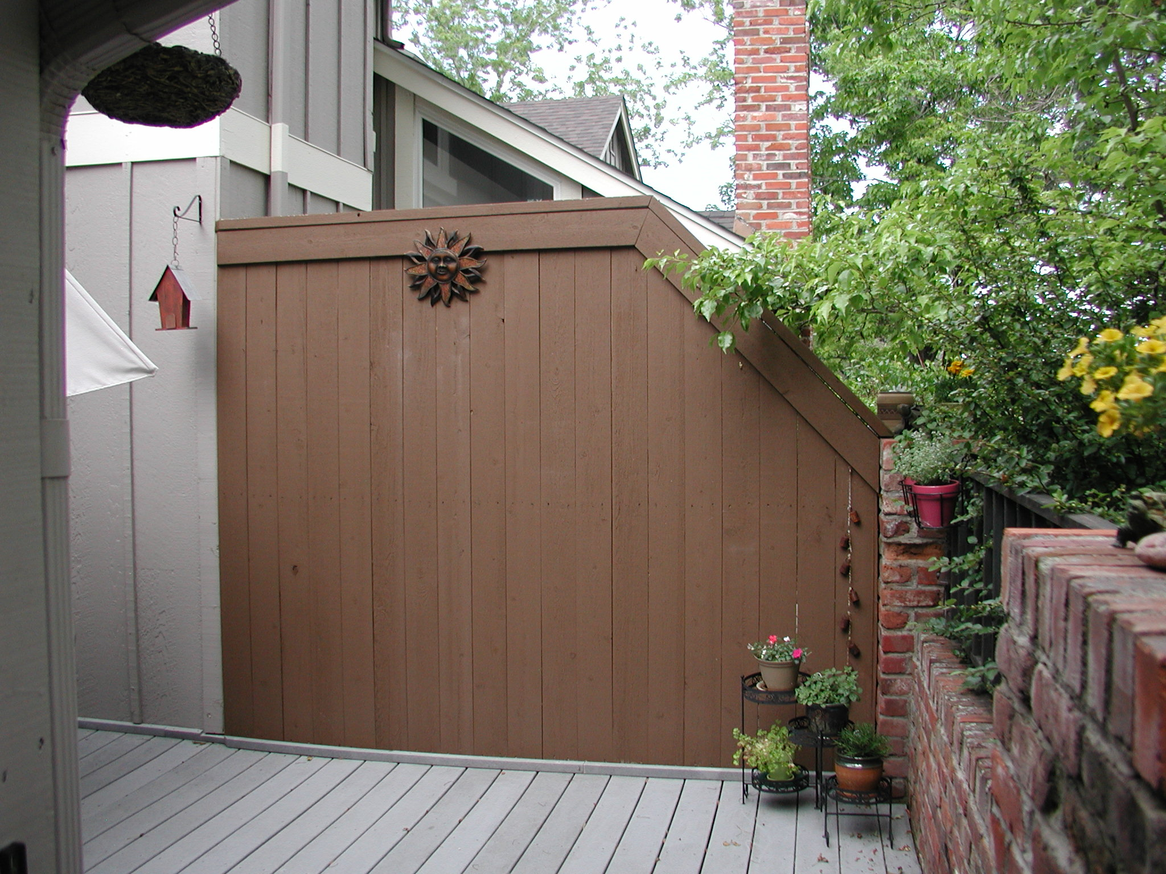
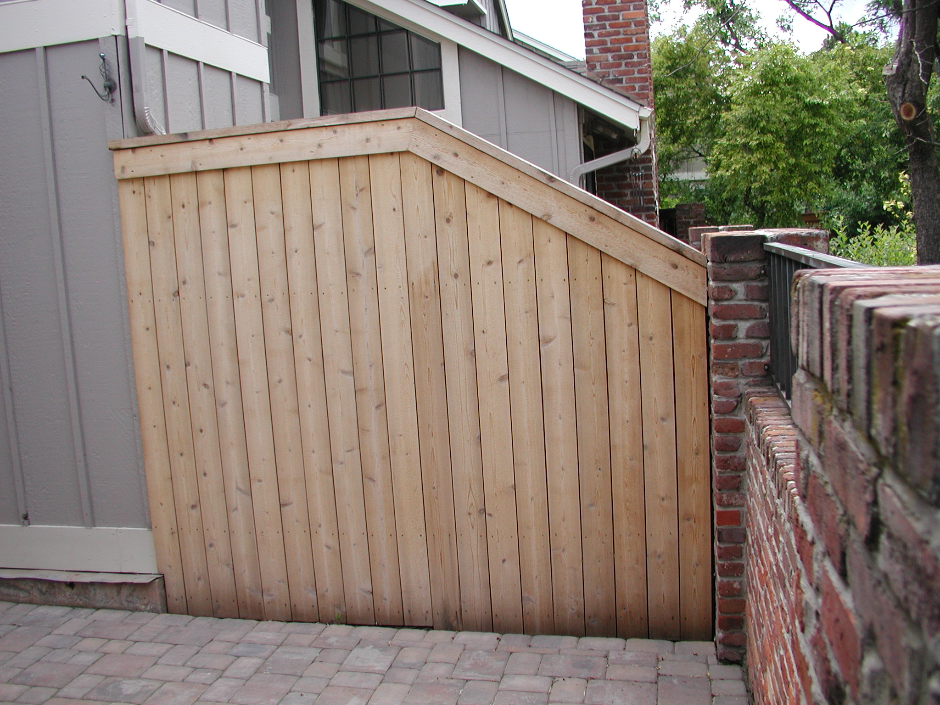

Dividing Fences
4. Definitions
4.1. Units of measure - English system of measures apply
4.2. Standard practices - Installation workmanship will be in accordance with approved contractor guidelines
5. General Requirements
5.1. Materials
5.1.1. Posts: pressure-treated cedar, 4X4
5.1.2. Rails: pressure-treated cedar, 2X4
5.1.3. Pickets: standard rough-cut cedar pickets, 1X6, "dog-eared" on one end
5.1.4. Trim (for end fence locations only): rough-cut cedar, 1X8
5.1.5. Concrete: Cast-in-Place 80# dry-mix bag [Recommended]
5.2. Size -. Dimensions of existing fence must be provided with Home Improvement Request
5.3. Stain Color - [Painting of replacement fences is NOT permitted.]
5.3.1. Behr Premium Natural Tone Semi Transparent
5.4. Form, Fit and Function - New fence shall match the old fence in orientation, alignment, height and configuration
5.5. Location
5.5.1. Dividing Fences: Fences located between the courtyards of 2 interior units
5.5.2. End Fences: Fences located between an end unit and common space area
6. Detailed Requirements
6.1. As an attachment to the related Home Improvement Request, Homeowner shall submit a
sketch/drawing of the fence elevation with dimensions detailing the fence profile
6.2. Existing fence shall be removed entirely, including existing concrete ballast at bottom of any post(s)
6.3. Construction
6.3.1. Hole for each new post shall be 30 inches deep
6.3.2. Posts shall be supported by cast-in-place concrete on all 4 sides and bottom. Top of post shall be trimmed flush to match top of top rail profile
6.3.3. Horizontal rails bottom and mid-rails shall be installed between posts and secured with a minimum of 2 fasteners
6.3.4 The top of End Fences shall be trimmed with 1X8 along each side of the fence and with 1X6 along the top of the fence (flat)
6.3.5. Fence Replacement Alternatives - End fences may be replaced with a used-brick wall with wrought-iron railing – (at Homeowners expense) [Consult with AB&M Committee for guidance]
6.4. Cost Allocation
6.4.1. Dividing Fences - As a jointly owned element of the adjacent Properties, it is recommended that neighbors equally split the furnished and installed cost of Dividing Fence replacement. Ongoing maintenance of Dividing Fences is the responsibility of both Homeowners.
6.4.2. End Fences - The expense, both furnished and installed, of an End Fence replacement shall
be borne by the Association, subject to approval by the Board. Ongoing maintenance of
End Fences is the responsibility of the Association.
6.5. Quality Control
6.5.1. Installation quality control of a Dividing Fence is the responsibility of the Homeowner and the Contractor
6.5.2. Installation quality control of an End Fence is the responsibility of the Association and the Contractor
6.6. Inspection
6.6.1. Jefferson County Building permit is NOT required
6.6.2. Members of the Architectural, Building & Maintenance Committee are available for
Inspection of non-permitted work
7. Notes
7.1. Hours of work - Work is permitted between the hours of 7:00 am and 5:00 pm Monday to
Friday and between 8:00 am and 5:00 pm on Saturday. Work is not allowed on Sunday.
7.2. Debris/waste disposal and site clean-up are the responsibility of the Homeowner and the
Contractor/Vendor
7.3. Contractors/Vendors are allowed to park in the alleyways while fulfilling their contractual obligation
7.4. Work shall be scheduled so as not to impact weekly trash pickup, snow removal and/or landscaping maintenance activities
7.5. The Sunset Ridge Townhouse Association Management Company shall be notified when the work begins and when the work is complete
7.6. A list of Contractors/Vendors (not qualified by the KCTOA) is available upon request (to be used at Homeowner's risk)
7.7. The Homeowner assumes all liability and responsibility for themselves, their
Contractors/Vendors, their assigns, and the work performed

